Developer Environment Setup Documentation
Introduction
This document outlines the steps taken to set up a developer environment. It includes the installation of necessary software, configurations, customizations, and any troubleshooting steps encountered during the process.
System Information
-Operating System: Windows 10 (64-bit)
Software Installation
1. Installing Git
Git is a version control system that manages and keeps track of the source code history.
Steps:
1. Downloaded the Git installer from [git-scm.com] (https://git-scm.com/).
2. Run the installer and follow the setup wizard.
3. During installation, I ensured that the following options are selected:
- Used Git from the Windows Command Prompt
- Checkout Windows-style, commit Unix-style line endings
- Used Windows' default console window
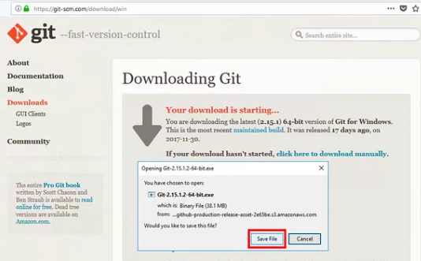

2. Installing Visual Studio Code
Visual Studio Code (VS Code) is a source-code editor developed by Microsoft.
Steps:
1. Downloaded the installer from [code.visualstudio.com] (https://code.visualstudio.com/).
2. Run the installer and follow the setup wizard.
3. Selected the necessary options during the installation process, such as adding PATH.
VS Code Installation
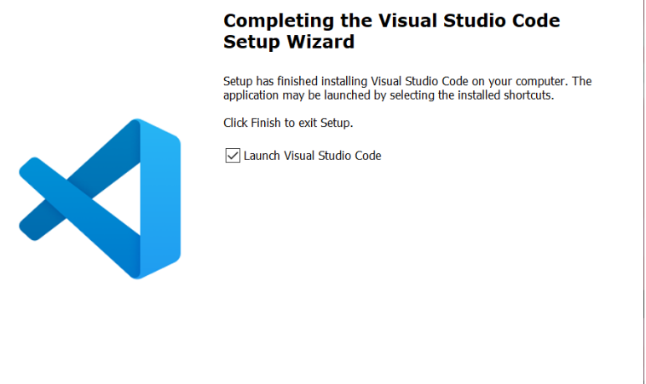
Configurations
1. Configuring Git
After installing Git, it's essential to configure your Git environment.
Steps:
1. Open Git Bash.
2. Set your username and email:
git config --global user.name "roygchege"
git config --global user. Email "roygchege@gmail.com"
3. Verify the configuration:
git config --list
2. Common Issues with VS Code

- Issue: Extensions are not installed or working correctly.
- Solution: Check your internet connection. If the issue persists, try reinstalling the extensions or VS Code itself.

